CO₂ Levels and Exercise Investigation
Aim: What were you trying to find out in this experiment? (1 mark)
______________________________________________________________________________________________________________________________________________________________________________
Hypothesis: What did you think was going to happen? (1 mark)
______________________________________________________________________________________________________________________________________________________________________________
Equipment List: (2 marks)
_____________________________________ _____________________________________
______________________________________ _____________________________________
______________________________________ _____________________________________
______________________________________ _____________________________________
______________________________________ _____________________________________

Procedure: What did you do? (dot points) (2 marks)
1.______________________________________________________________________________________2.______________________________________________________________________________________3.______________________________________________________________________________________4.______________________________________________________________________________________5.______________________________________________________________________________________6.______________________________________________________________________________________
Diagram: Draw a picture of what you did and label everything (3 marks)

Independent Variable (what did you change?): _______________________________________________
Dependent Variable (what did you measure?): _______________________________________________
Control Variables (what did you keep the same?): ____________________________________________________________________________________________________________________________________________________________________________________________________________________________________________________________________
(3 marks)
Complete the table and calculate the averages (3 marks)
 | Time for Bromothymol blue to change colour (sec)
Amount of exercise | Trial 1 | Trial 2 | Trial 3 | Average

Draw a line graph on the next page using the averages (5 marks)
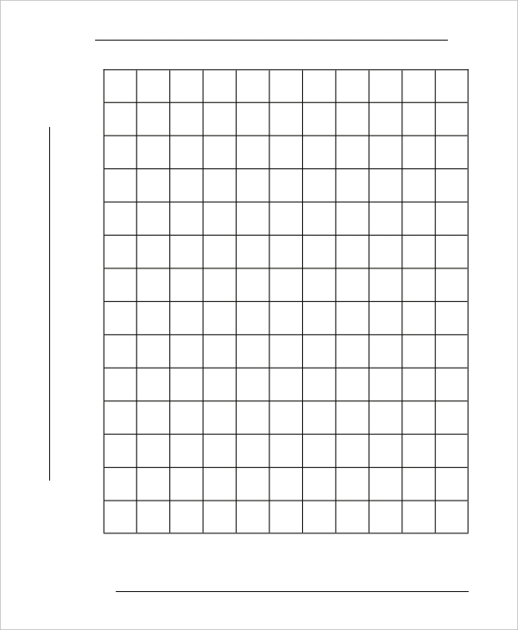
How much exercise
Time: ( )
Graph Title:

Discussion:
What pattern did you find in your data? (did it go up, down, the same) (2 marks) ______________________________________________________________________________________________________________________________________________________________________________________________________________________________________________________
What were some sources of error in your experiment? (error in measurement, not accurate, problems) (2 marks) ______________________________________________________________________________________________________________________________________________________________________________________________________________________________________________________
How could you improve your experiment for next time? (be more accurate, fix problems… HOW) (2 marks) ______________________________________________________________________________________________________________________________________________________________________________________________________________________________________________________
Conclusion:
Was your hypothesis supported? Yes/no: _________________________________________________(1 mark)

